Suprarenal glands - gross anatomy

Synonyms and etymology
Adrenal glands (Adrenal - adjacent to renal)
Suprarenal glands (suprerenal - above the kidney)

Functions
Medulla - acts as sympathetic ganglion, secretes adrenaline and noradrenaline
Cortex - has three layers
- Zona glomerulosa - secrete Mineralocorticoids (aldosterone)
- Zona fasiculata - secrete corticosteroids (cortisol)
- Zona reticularis - secrete sex steroids (dehydroepiandrosterone, androstenodione)

Location
Antero superior to upper pole of kidneys
In epigastrium

Shape
Right suprarenal gland - wedge shaped
Left suprarenal gland - Semilunar

Change in size
At birth - suprarenal glands are large (about one third the size of kidney)
In adults - the size is 1/30th the size of kidney

Hilum of suprarenal gland
Right suprerenal gland hilum - near anterior border, right suprarenal vein emerges
Left suprarenal gland hilum - near lower part of anterior surface, left suprarenal vein emerges
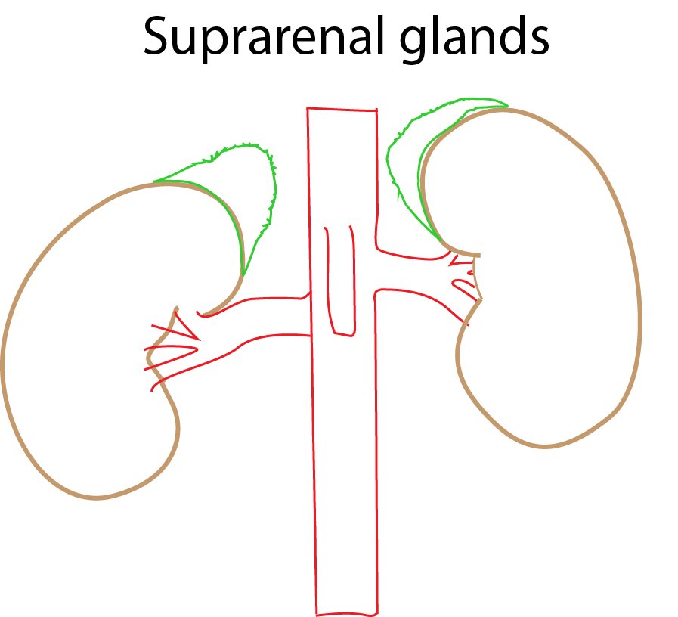
Suprarenal glands - appreciate the different shapes on right and left sides

Coverings
- Deeper - loose areolar tissue with perirenal fat
- Outer - Renal fascia (encloses kidney as well, separated by a septum)

Arterial supply
Three arteries
- Superior suprarenal artery - branch of inferior phrenic artery
- Middle suprarenal artery - branch of abdominal aorta
- Inferior suprarenal artery - branch of renal artery

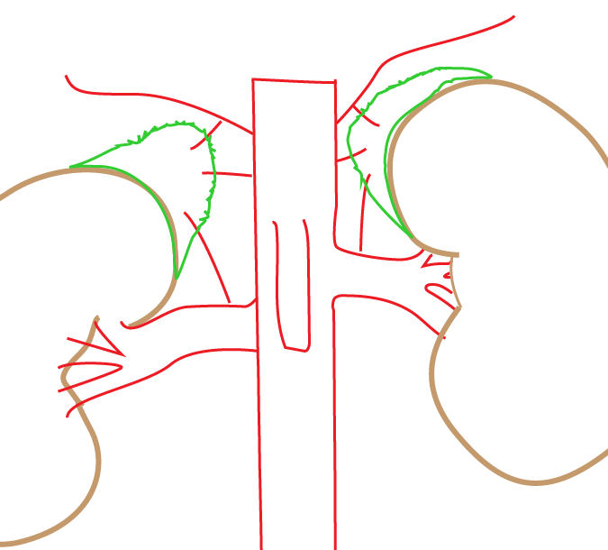
Superior suprarenal artery

Venous drainage
Right suprarenal vein - drains directly into inferior vena cava
It is short and is difficult to ligate
Left suprarenal vein - drains into left renal vein opposite to the drainage of left gonadal vein

Right suprarenal vein
Drains into the inferior vena cava

Left suprarenal vein
Drains into the left renal vein
Opposite to left testicular vein in males

Left varicocele
Left sided varicocele is more common
- Left testis is at lower level
- Left testicular vein may be compressed by loaded sigmoid colon
- Left suprarenal vein carrying sympathomimetic compounds drains opposite to left testicular vein to the left renal vein

Applied aspects - functional abnormalities
Chronic adrenal insufficiency - Addison's disease
Acute adrenal insufficiency - adrenal crisis
Hypersecretion of corticosterone - Cushing syndrome

Applied aspects – adrenalectomy
Adrenal veins are ligated first in cases of pheochromocytomas. This avoids systemic release of catecholamines through adrenal veins
Anatomical complications during adrenalectomy
Vascular injuries - left sided adrenalectomy: injury to inferior mesenteric vein, middle and left colic arteries, superior renal polar arteries. Right sided adrenalectomy: injury to hepatic veins, inferior vena cava and superior renal polar arteries
Organ injury - left sided adrenalectomy: splenic injury, pancreatic injury. Right sided adrenalectomy: injury to liver, duodenum

